Install the Pillow Library:

**Option 1:** Install via ArcGIS Pro built-in Package Manager

* Select Python 🡪 Manage Environments 🡪 Clone Default
  + This operation will clone the default ArcGIS Pro Conda Python Environment. (As we cannot directly install Pillow on the default environment ☹ )
    - Cloning will take a few minutes to complete
  + 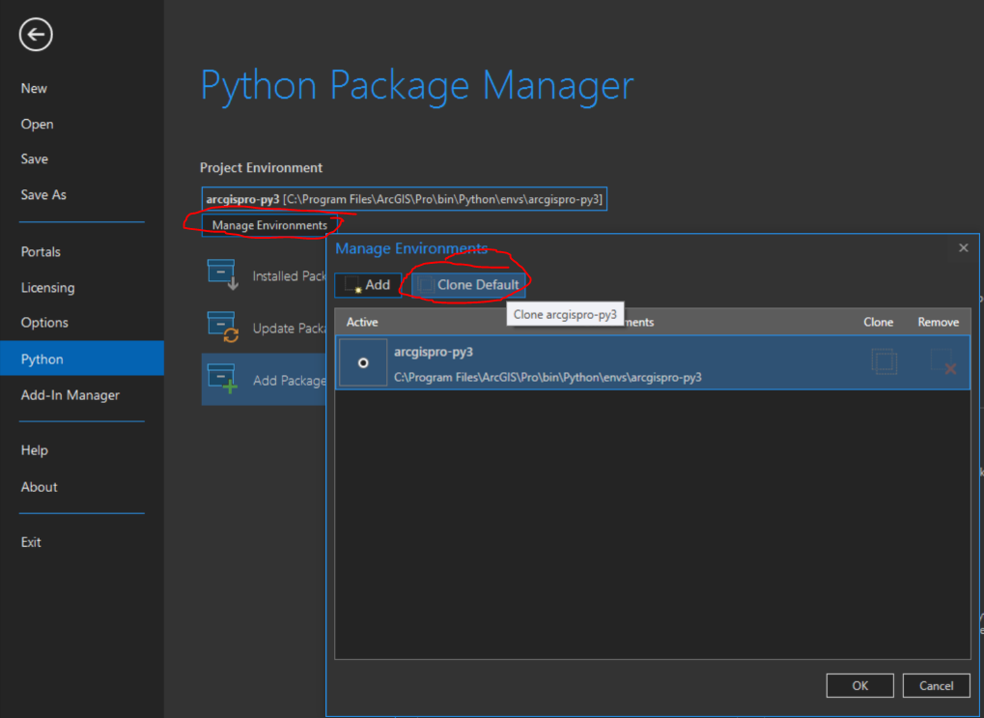
* Select the Cloned Environment.
  + 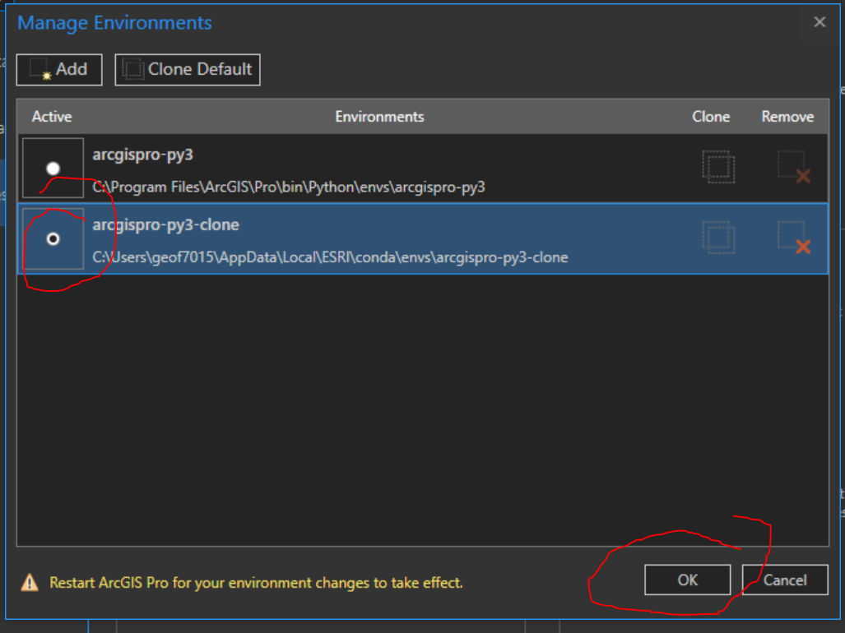
* Restart ArcGIS Pro
* Navigate Python🡪 Add Packages.
  + Use the search dialogue box to find and thin install the “pillow” package
  + 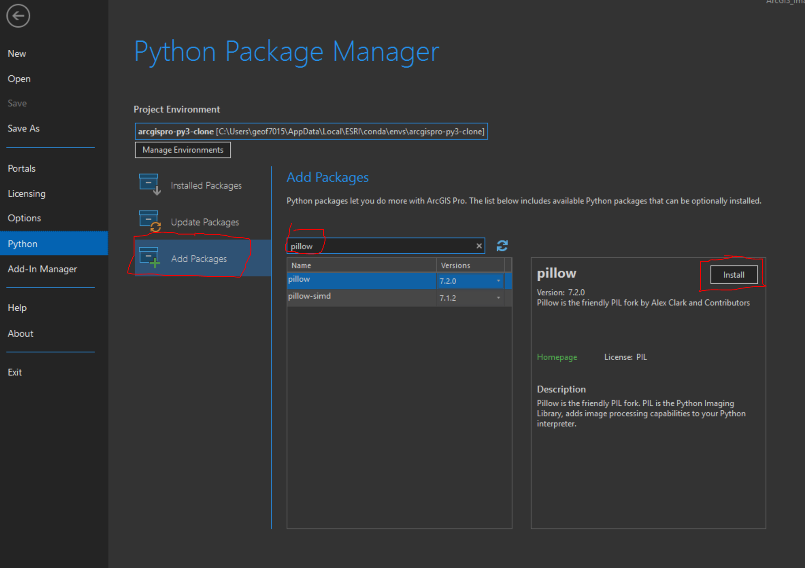
* The Pillow Installation will take several minutes to complete... Sit back relax and grab a coffee.

**Option 2:**  Install to the default ArcGIS Pro Conda Environment or Copied ArcGIS Pro Conda Environment using the command prompt.

*\*\*\*(USE AT YOUR OWN RISK!) As errors installing on the ArcGIS Pro Default Conda Environment may require a Hard Reinstall of ArcGIS Pro.\*\*\**

* Run the Command prompt as Administrator
* Type: cd C:\Program Files\ArcGIS\Pro\bin\Python\Scripts
  + Press Enter
* Type: conda install -c anaconda pillow
  + Press enter
* Installation will commence for the Pillow Package
  + 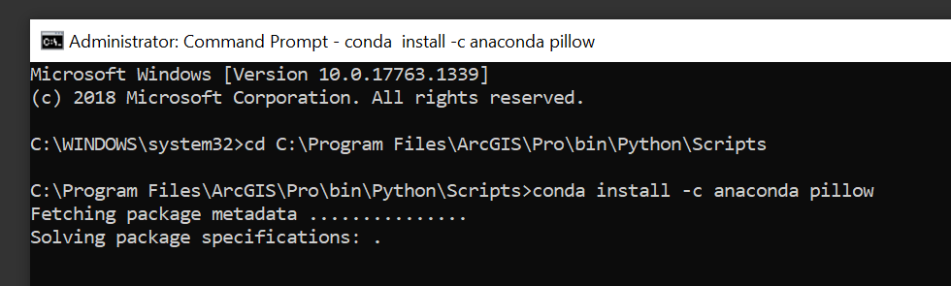
* When Prompted to proceed type y and press enter
  + 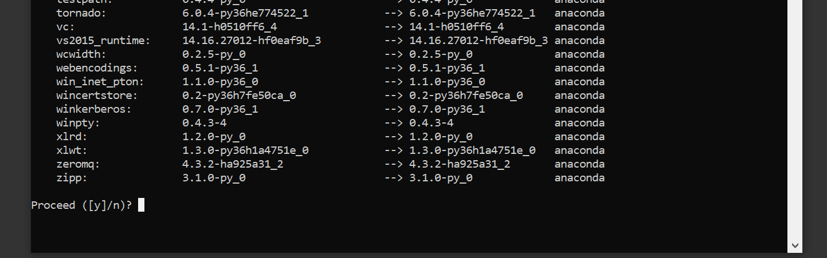
  + **Note: Installation may stall at the Jupyter Notebook section. Just press “Enter” and wait and “Enter” and wait again each time it stalls.
  + Once complete type: conda list
    - This will check and ensure pillow has been installed
    - 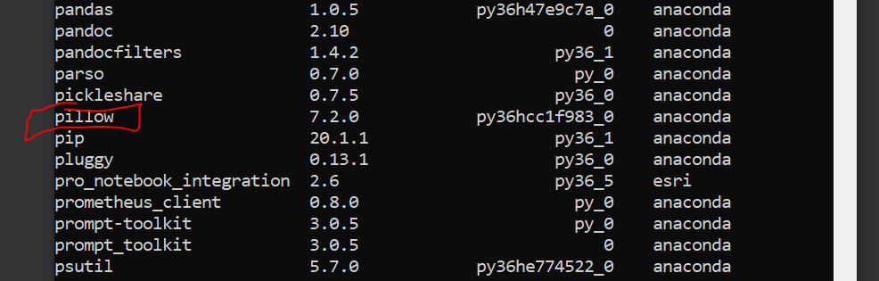

**Applying Seamless Textures to Imagery**

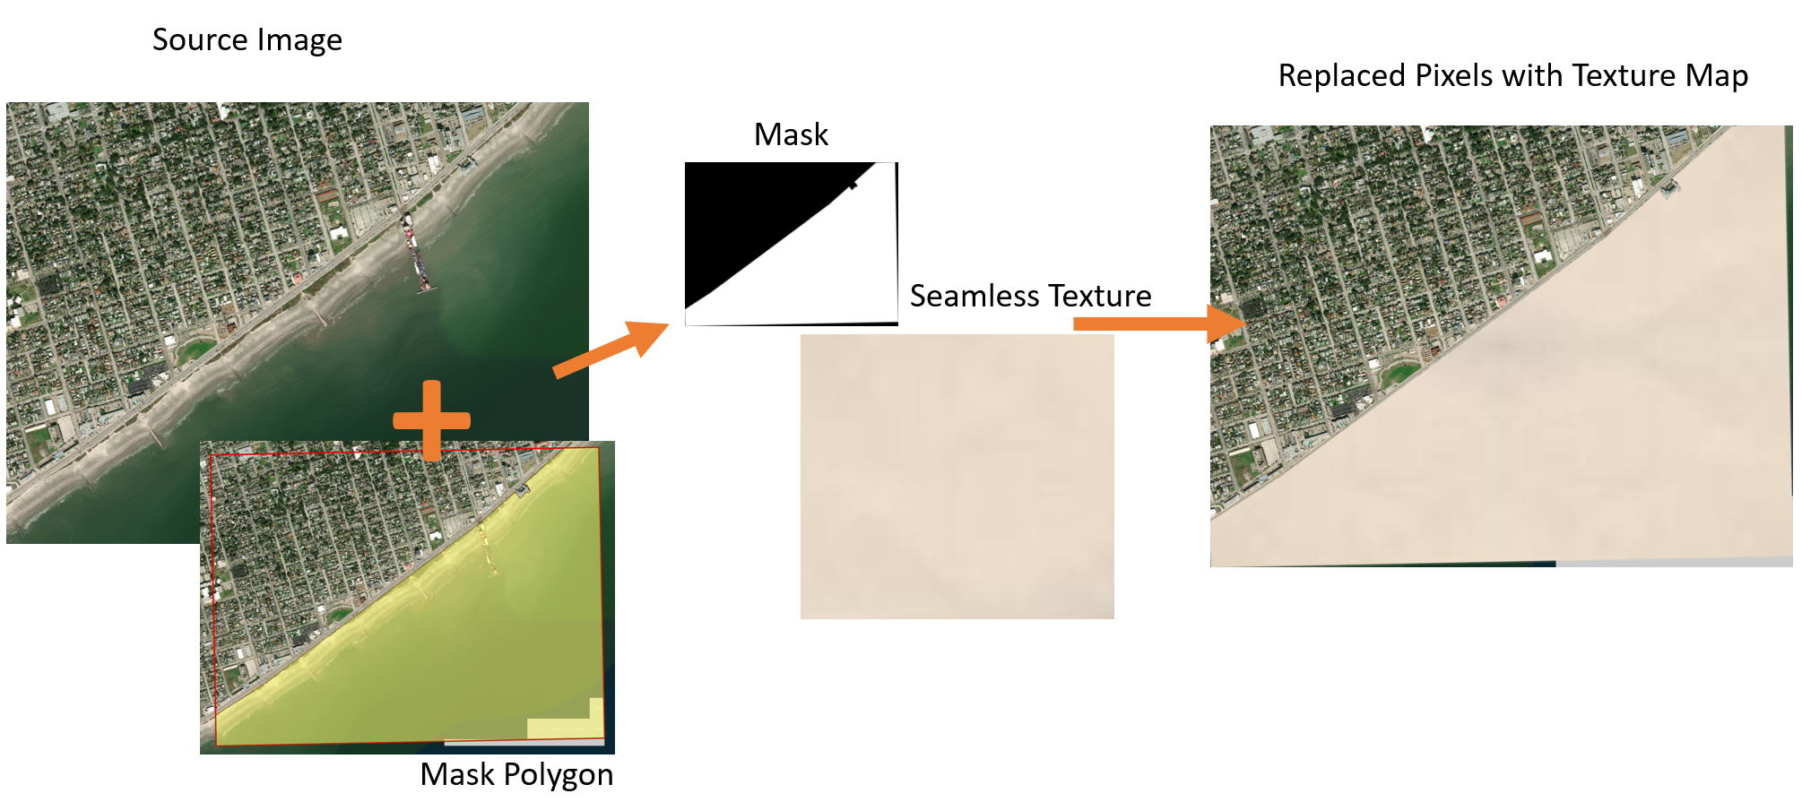

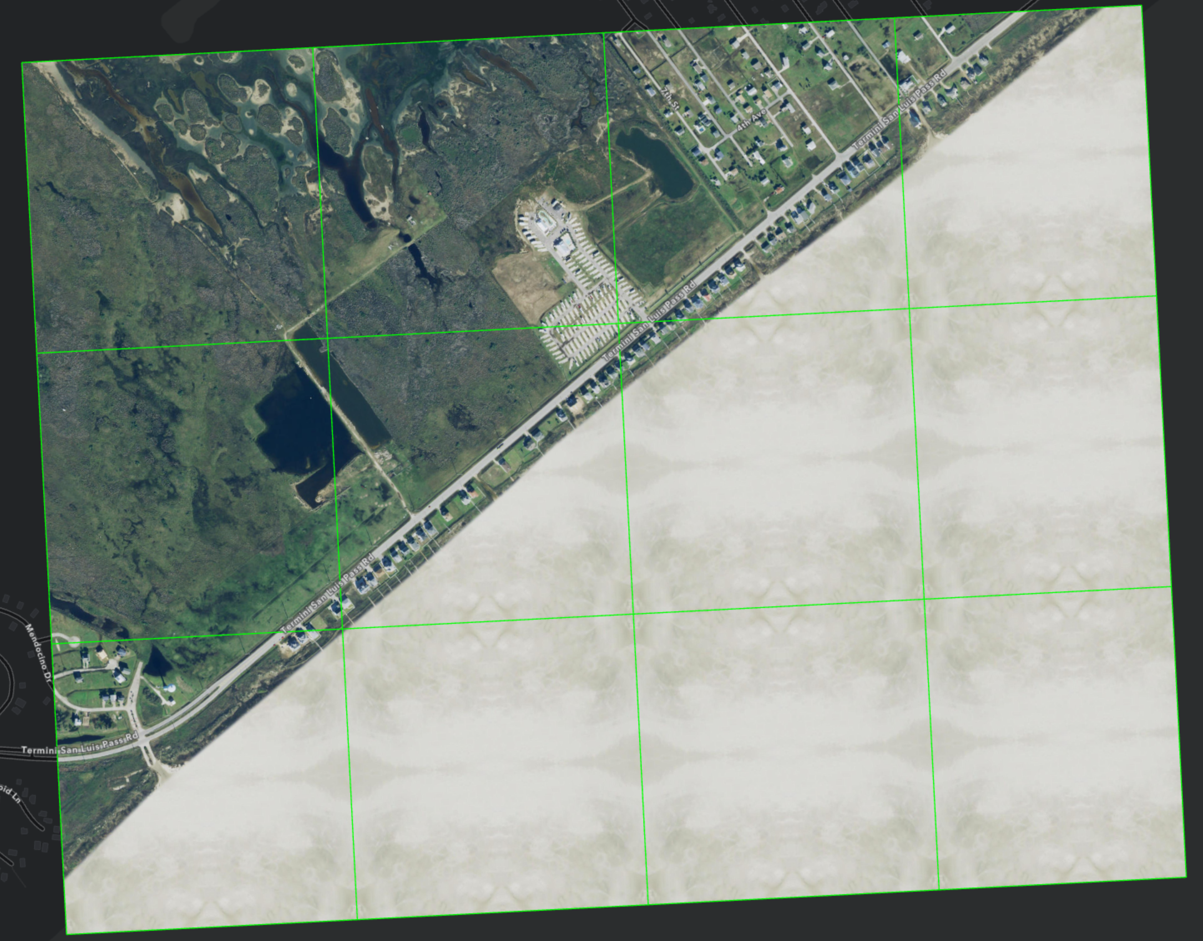

**There are two approaches to texturing Ortho-Imagery:**

1. App**roach 1:** Seamless Image Tile/s where the extent is a rectangle or square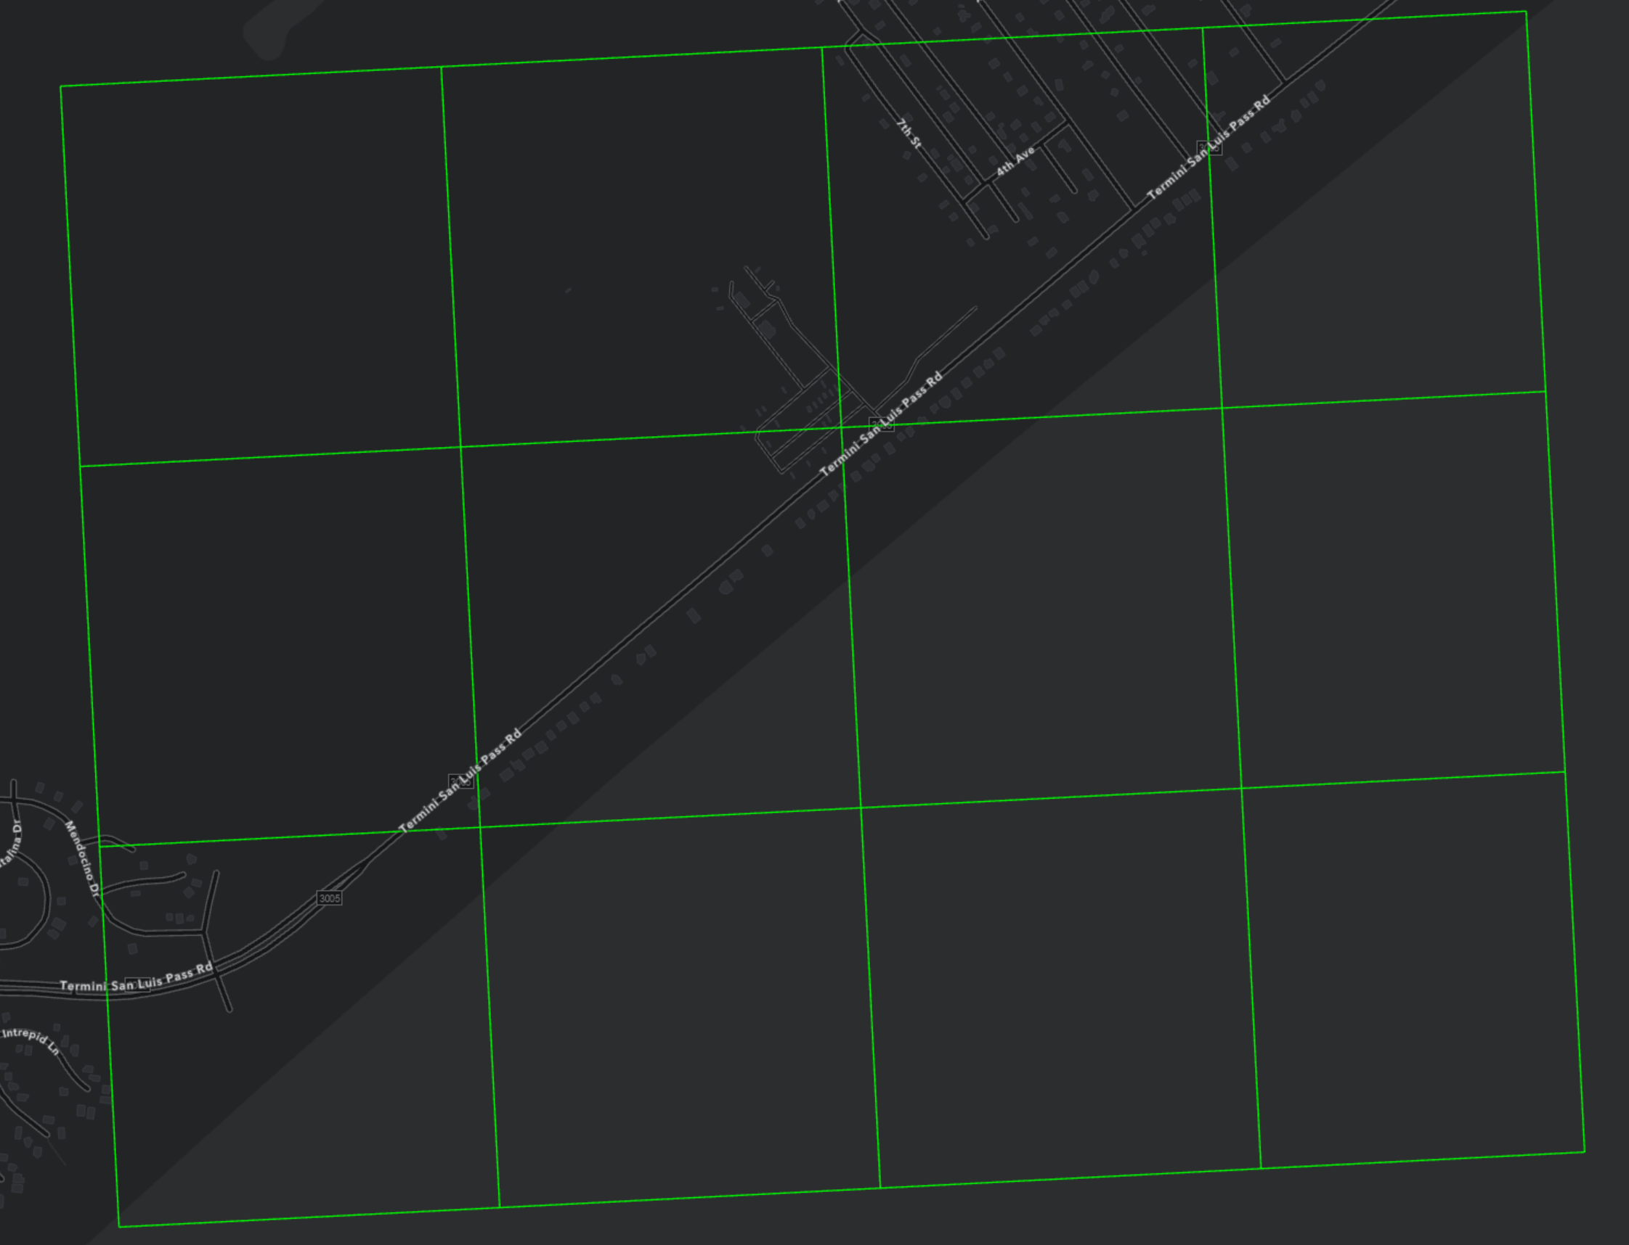
   1. In the Task Workflow:
      1. Prepare Imagery 🡪 Optimally Tile Ortho-Imagery
      2. Raster Masking 🡪 Generate Polygon Masks
      3. Raster Masking 🡪 Replace Masked Areas with Texture Maps.
2. **Approach 2:** Ortho-Imagery Tile/s that are dispersed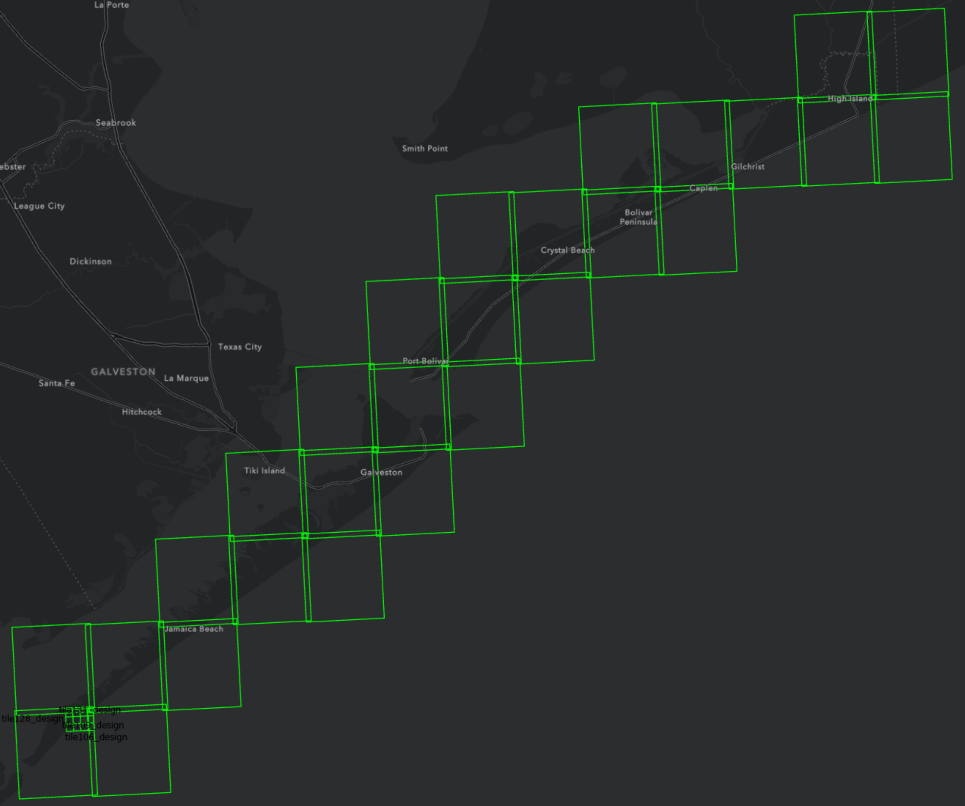
   1. In the Task Workflow:
      * Prepare Imagery 🡪 Optimally Tile Ortho-Images (Bulk)
      * Raster Masking 🡪 Replace Masked Area with TextureMask (Bulk)

There are a additional tools that can be found in the “ArcGIS_Image_Designer.tbx” toolbox.

1. Tool for subsetting/extracting an image from existing imagery to aid in the creation of generating seamless texturemaps

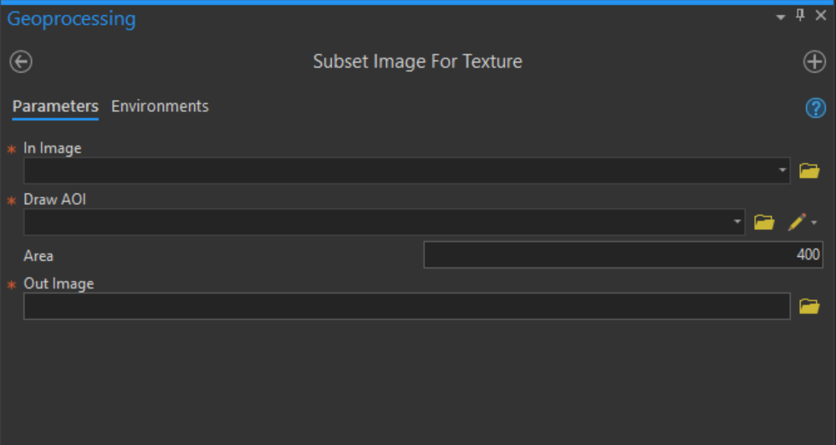

1. A tool for converting the subsetted image into a seamless textureMap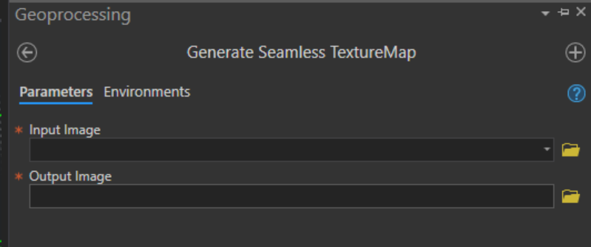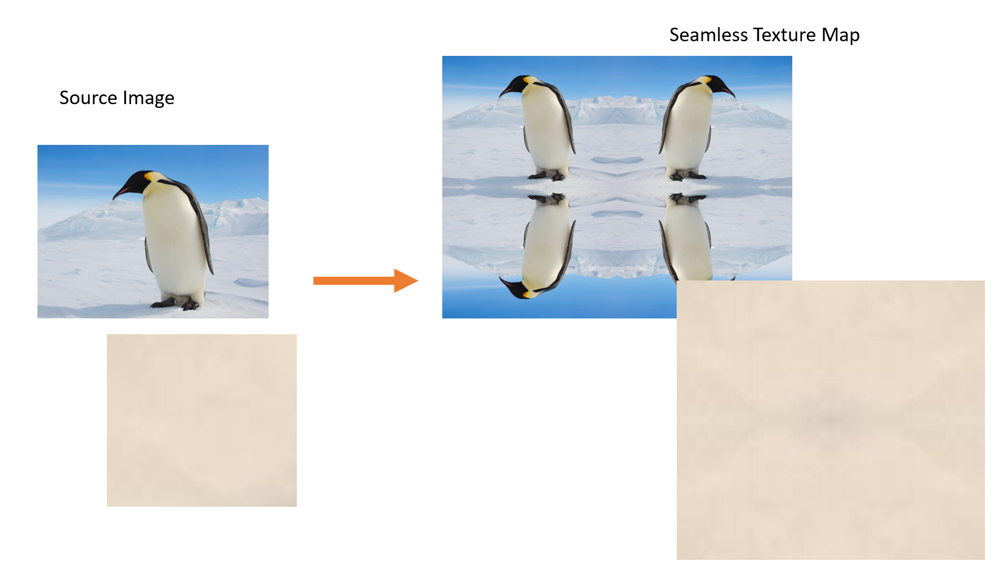
   1. Additionally, you may want to use the stamp-clone tool in Adobe Photoshop to help further clean-up the generated seamless image. Also, I recommend working with imagery in the .jpg format for these steps.